**doBCON** steps:

1. Create a new folder under “UD/doBCON” with the record name you want, and a file inside it with the same name that contains component list

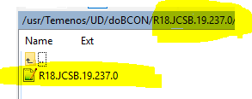

1. It should be formatted as **Application.Name>Record.Name**

*make sure there are no empty spaces

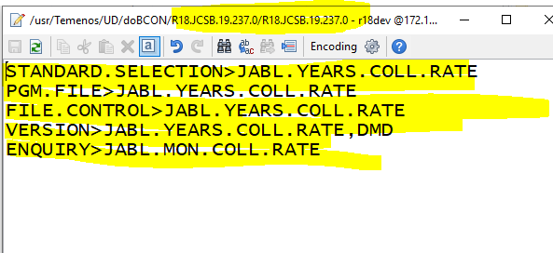

1. Call the command “**doBCON”** with that name of the folder

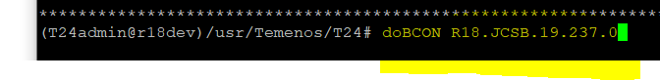

1. You can do other things while it simulates a T24 session, when it ends you will see the green END line, and command input at current working directory given back to user

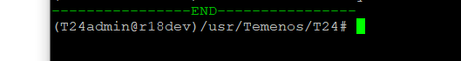

1. Do a refresh to the view of that folder and then you’ll see the tar file

